Exploration Storyboard Instructions
Please describe or sketch any pictures or graphics that would be used to help the student understand the concept. Also describe any objects that can be dragged and dropped into another area of the screen. You could use: moving lines on graphs, addition/subtraction buttons, handles that rotate items, items that change color, etc.
Include how many problems should be presented. Should something be displayed when the student hovers the pointer over an object? Should something be highlighted when clicked? Should a box or circle appear around the object? Should there be audio feedback? What feedback or guidance should the students receive, based on which wrong or right answers?
Here is an example:
General Overview: To teach students one-digit multiplication by visualizing groups of objects.
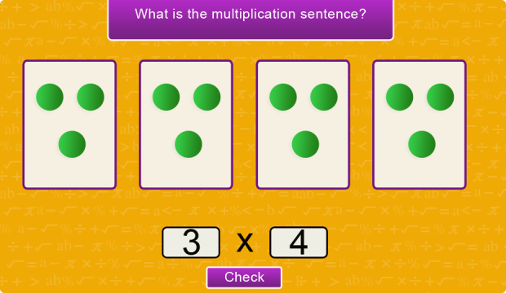
Topic: 1-digit multiplication
Screen: 1
Instructions: When the exploration starts, the student can only interact with the two text boxes, which are blank. The student must determine the numbers based on how many groups, and how many per group. In this case, the student could either answer “3” and “4”, or “4” and “3”. Answering correctly takes the user to Stage 2.

Screen: 2
Instructions: An equal sign and another text box appear. This text box is not selectable by the student. Instead, the student clicks or taps the dots. Each time a new dot is tapped, the number in the product box increases by one. The dots can be tapped in any order. Also, the dot is labeled with whatever number it was in being tapped. A piece of audio will play reading the number that has been tapped. As long as the number in the product box does not equal the product (12 in this example), it remains red.

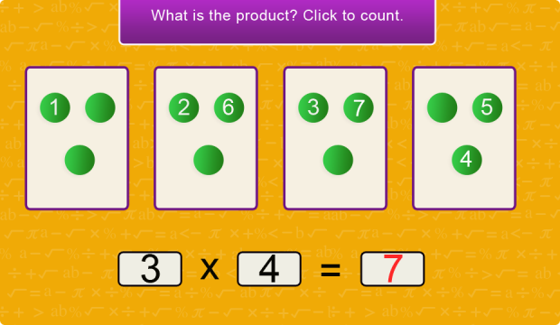
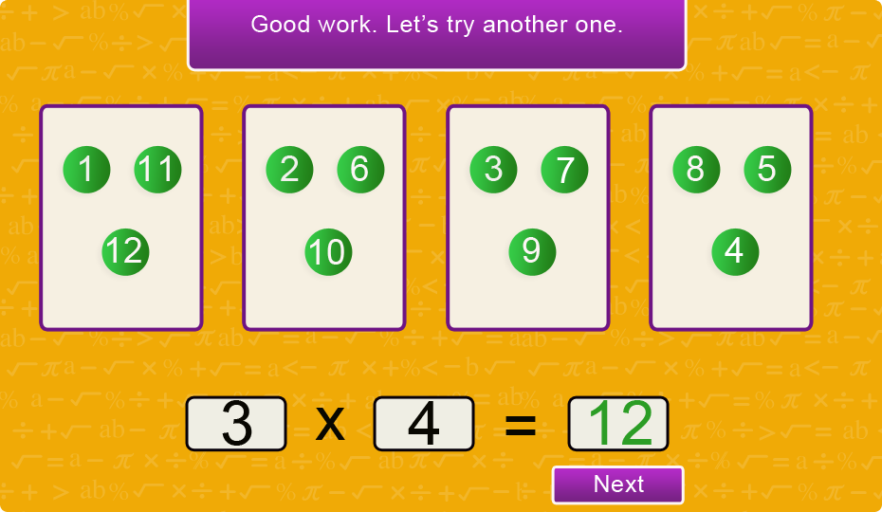
Screen: 2b
Instructions: Once all of the dots have been tapped, the exploration congratulates the user, turns the product text green, and displays the “Next” button. Should have no more than 5 problems. The maximum product is 20. The factors are randomly generated. There should always be at least 2 groups.

First, provide a General Overview of the concept that would be reinforced in the exploration and briefly describe how the exploration would accomplish this goal.
As you write the overview, keep this questions in mind:
Is this an introduction or a review of the objective?
What are the pre requisites? E.g. knowledge of decimals for a money exploration
What is the target grade level (functional grade level)?
What is the difficulty level? E.g. number of digits, place value, unlike denominators, negatives
Which special cases need to be taught, such as zero or one?
What are common mistakes when working on this topic?
Are there any wrong answers that should result in correcting feedback, e.g. you need to multiply instead of divide. Try again.
For a geometry exploration: determine pre requisites, such as congruency and similarity.

General Overview________________________________________________________________________
__________________________________________________________________________________________________________________________________________________________________________________________________________________________________________________________________________________________________________________________________________________________________________________________
_____________________________________________________________________________________________________________________________________________________________________________________________
_____________________________________________________________________________________________________________________________________________________________________________________________
_____________________________________________________________________________________________________________________________________________________________________________________________
_____________________________________________________________________________________________________________________________________________________________________________________________
_____________________________________________________________________________________________________________________________________________________________________________________________

Exploration Storyboards
Screen:________________________________
Instructions: ____________________________ _______________________________________________________________________________________________________________________________________________________________________________________________________________________________________________________________________________________________________________________________________________________________

____________________________________________________________________________________________________________________________________________________________________________________________________________________________________________________________________________________________________________________________________________________________________________________________
Contact Name: _________________________Email Address:____________________________________________
School: ________________________________________Class: __________________________________________
Address: ______________________________________________________________________________________
Email your Storyboard to: exploration@ascendmath.com
____________________________________________________________________________________________________________________________________________________________________________________________________________________________________________________________________________________________________________________________________________________________________________________________
Screen:________________________________
Instructions: ____________________________ _______________________________________________________________________________________________________________________________________________________________________________________________________________________________________________________________________________________________________________________________________________________________

